





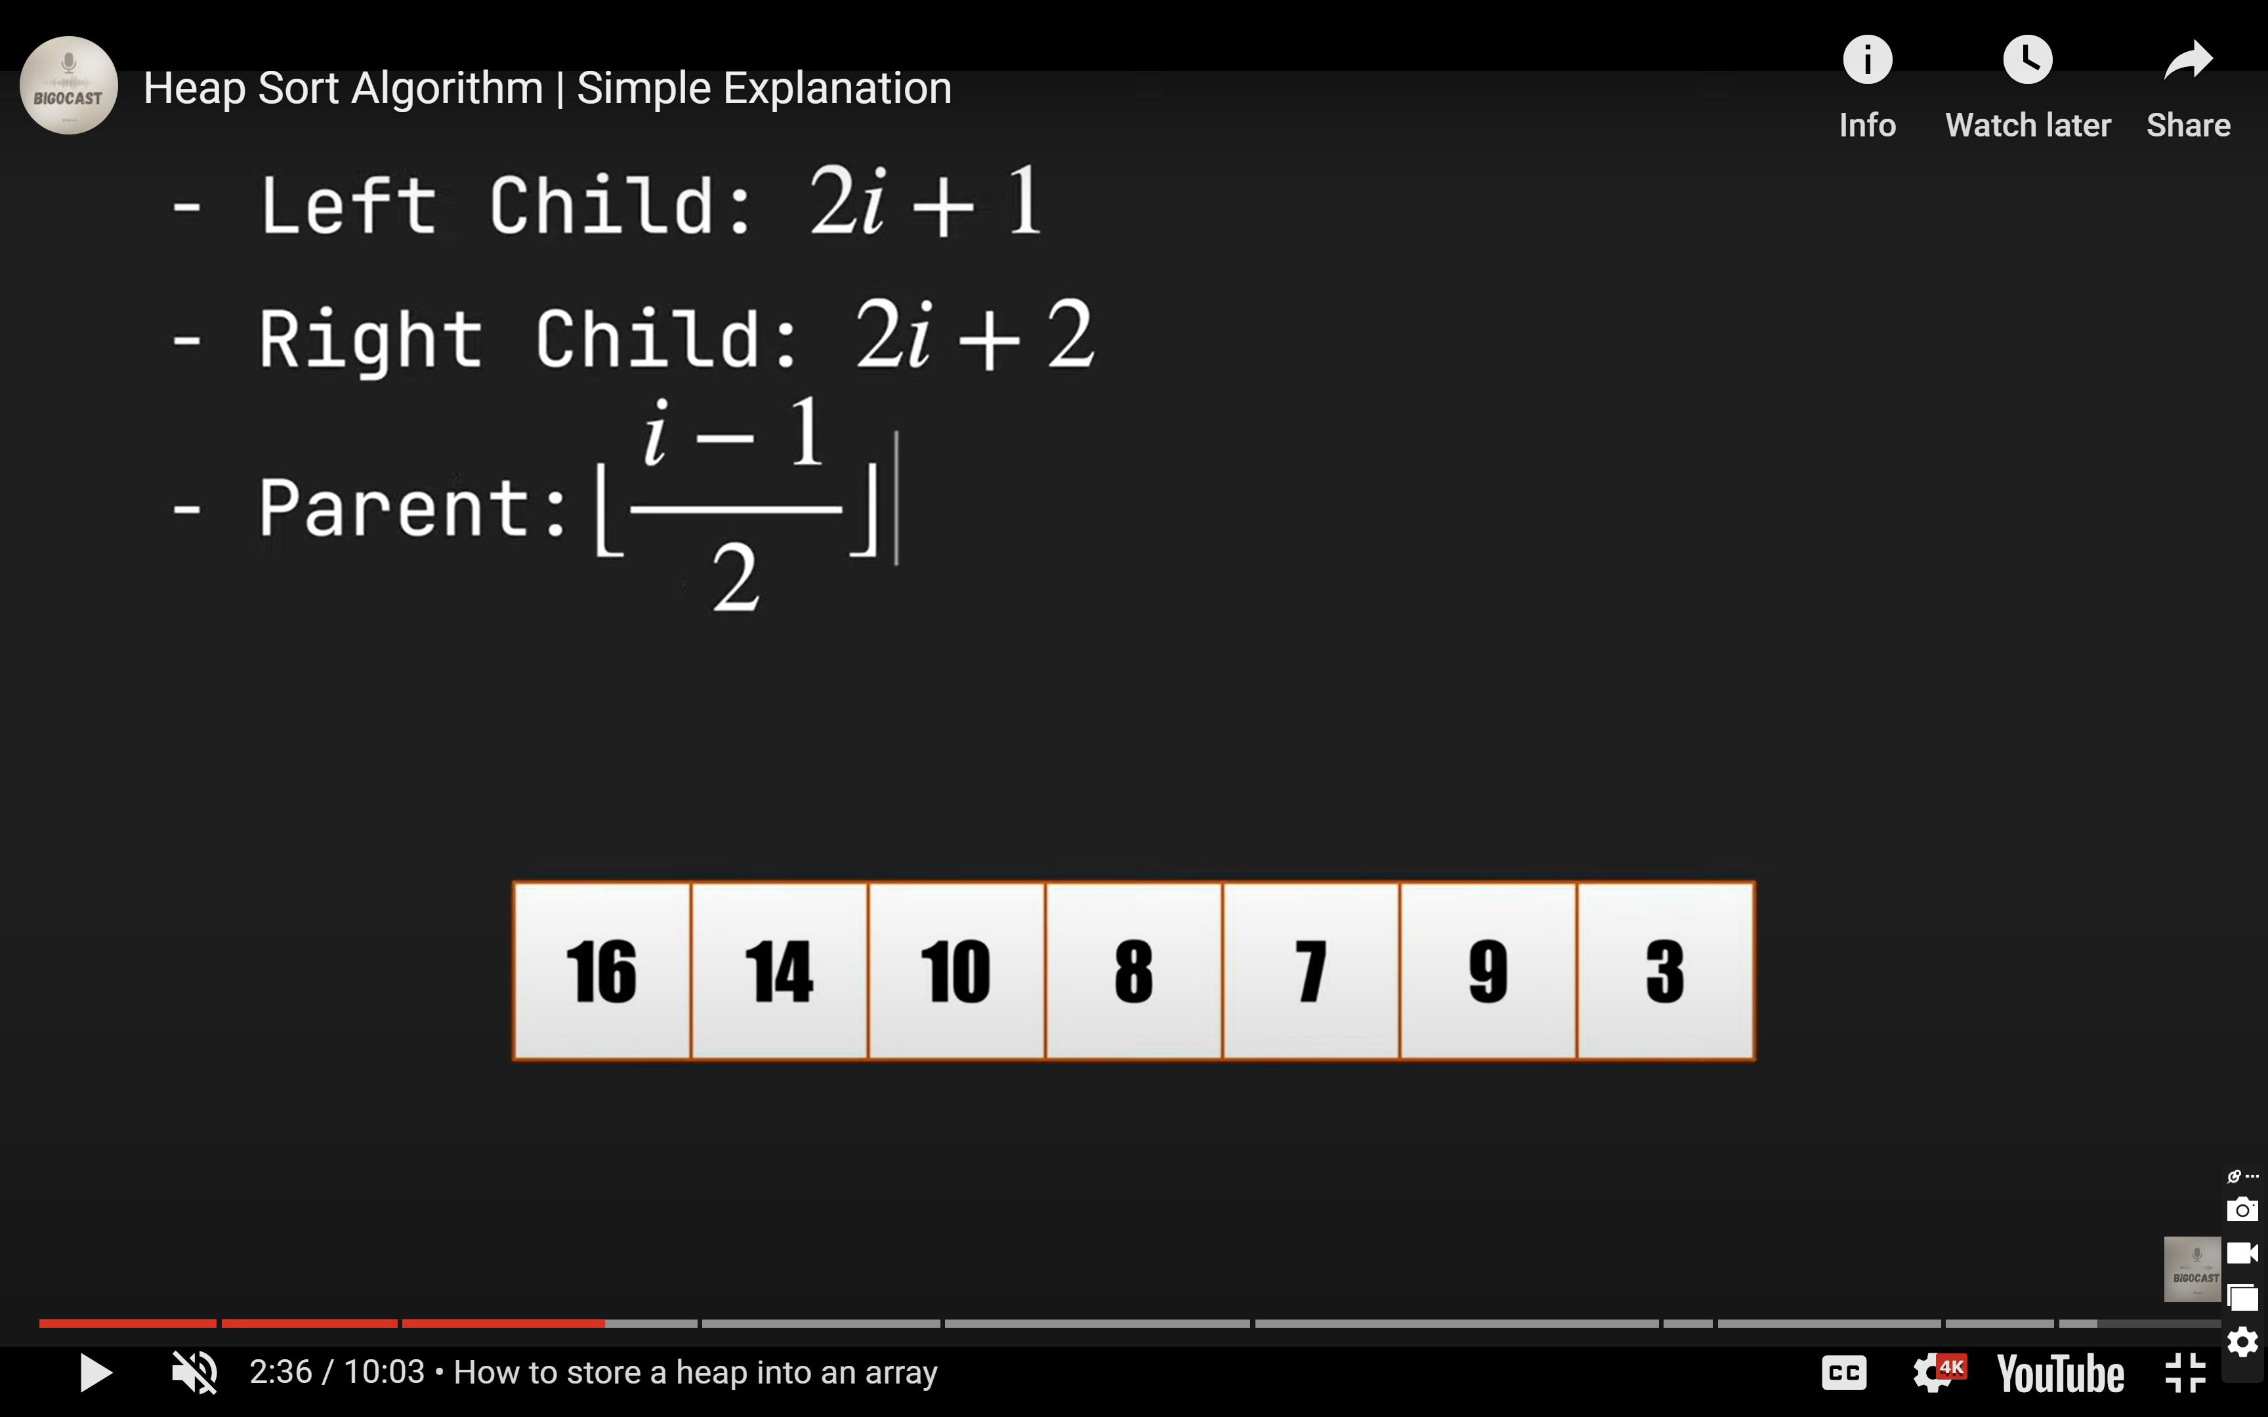





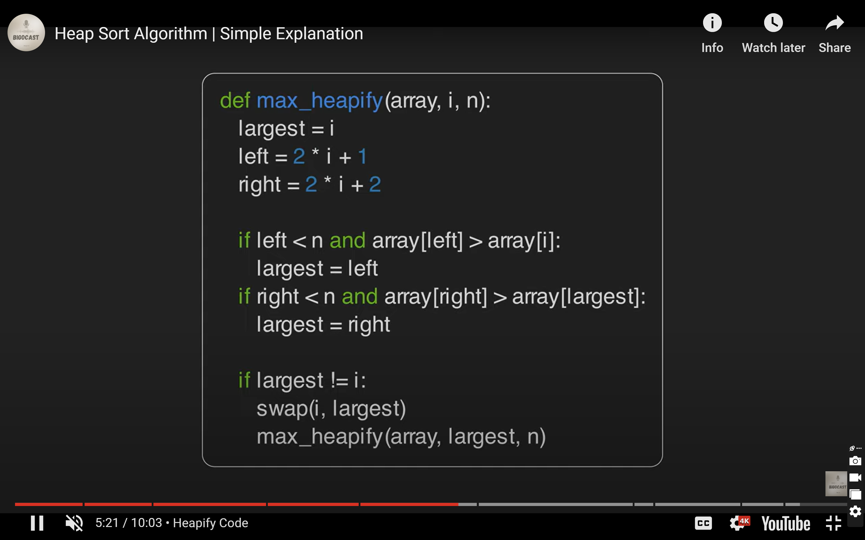





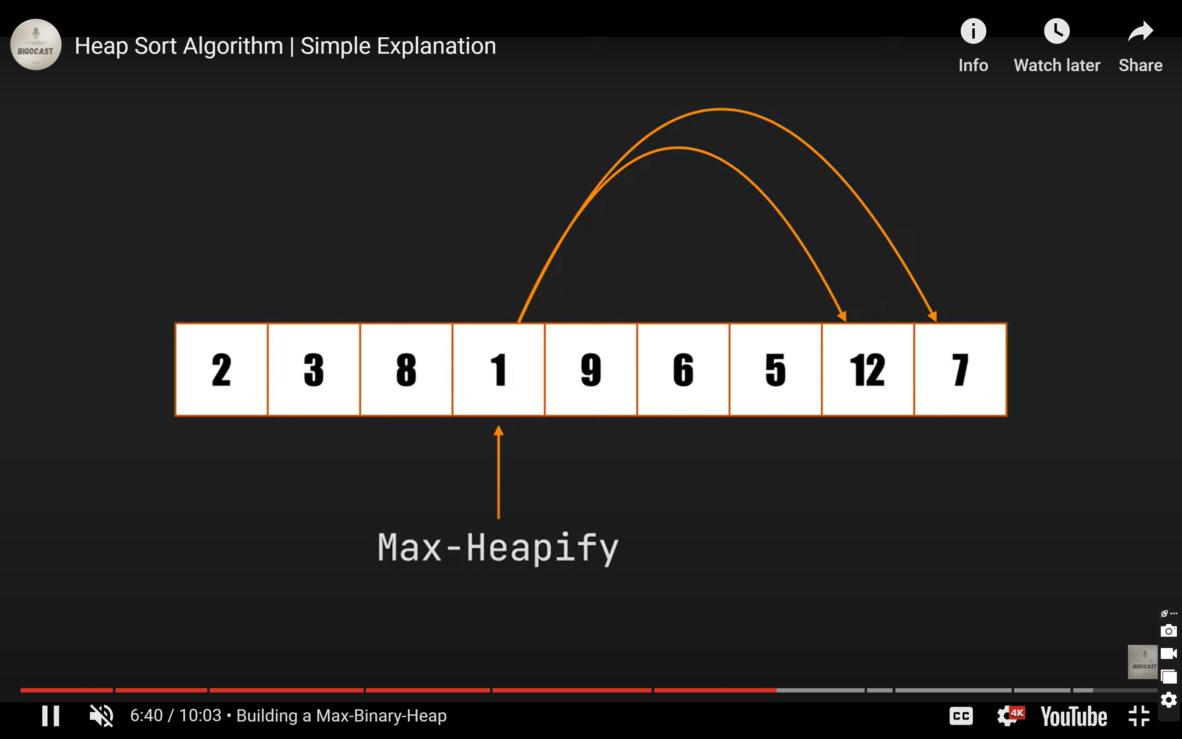





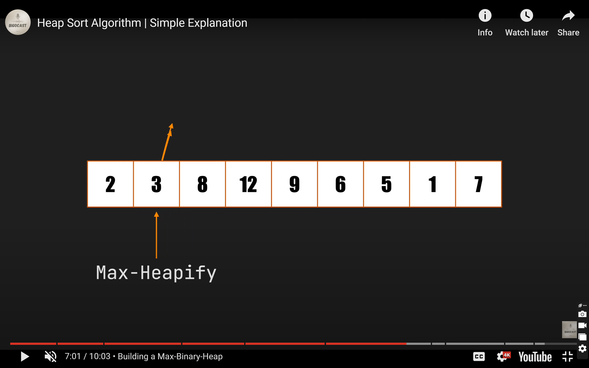

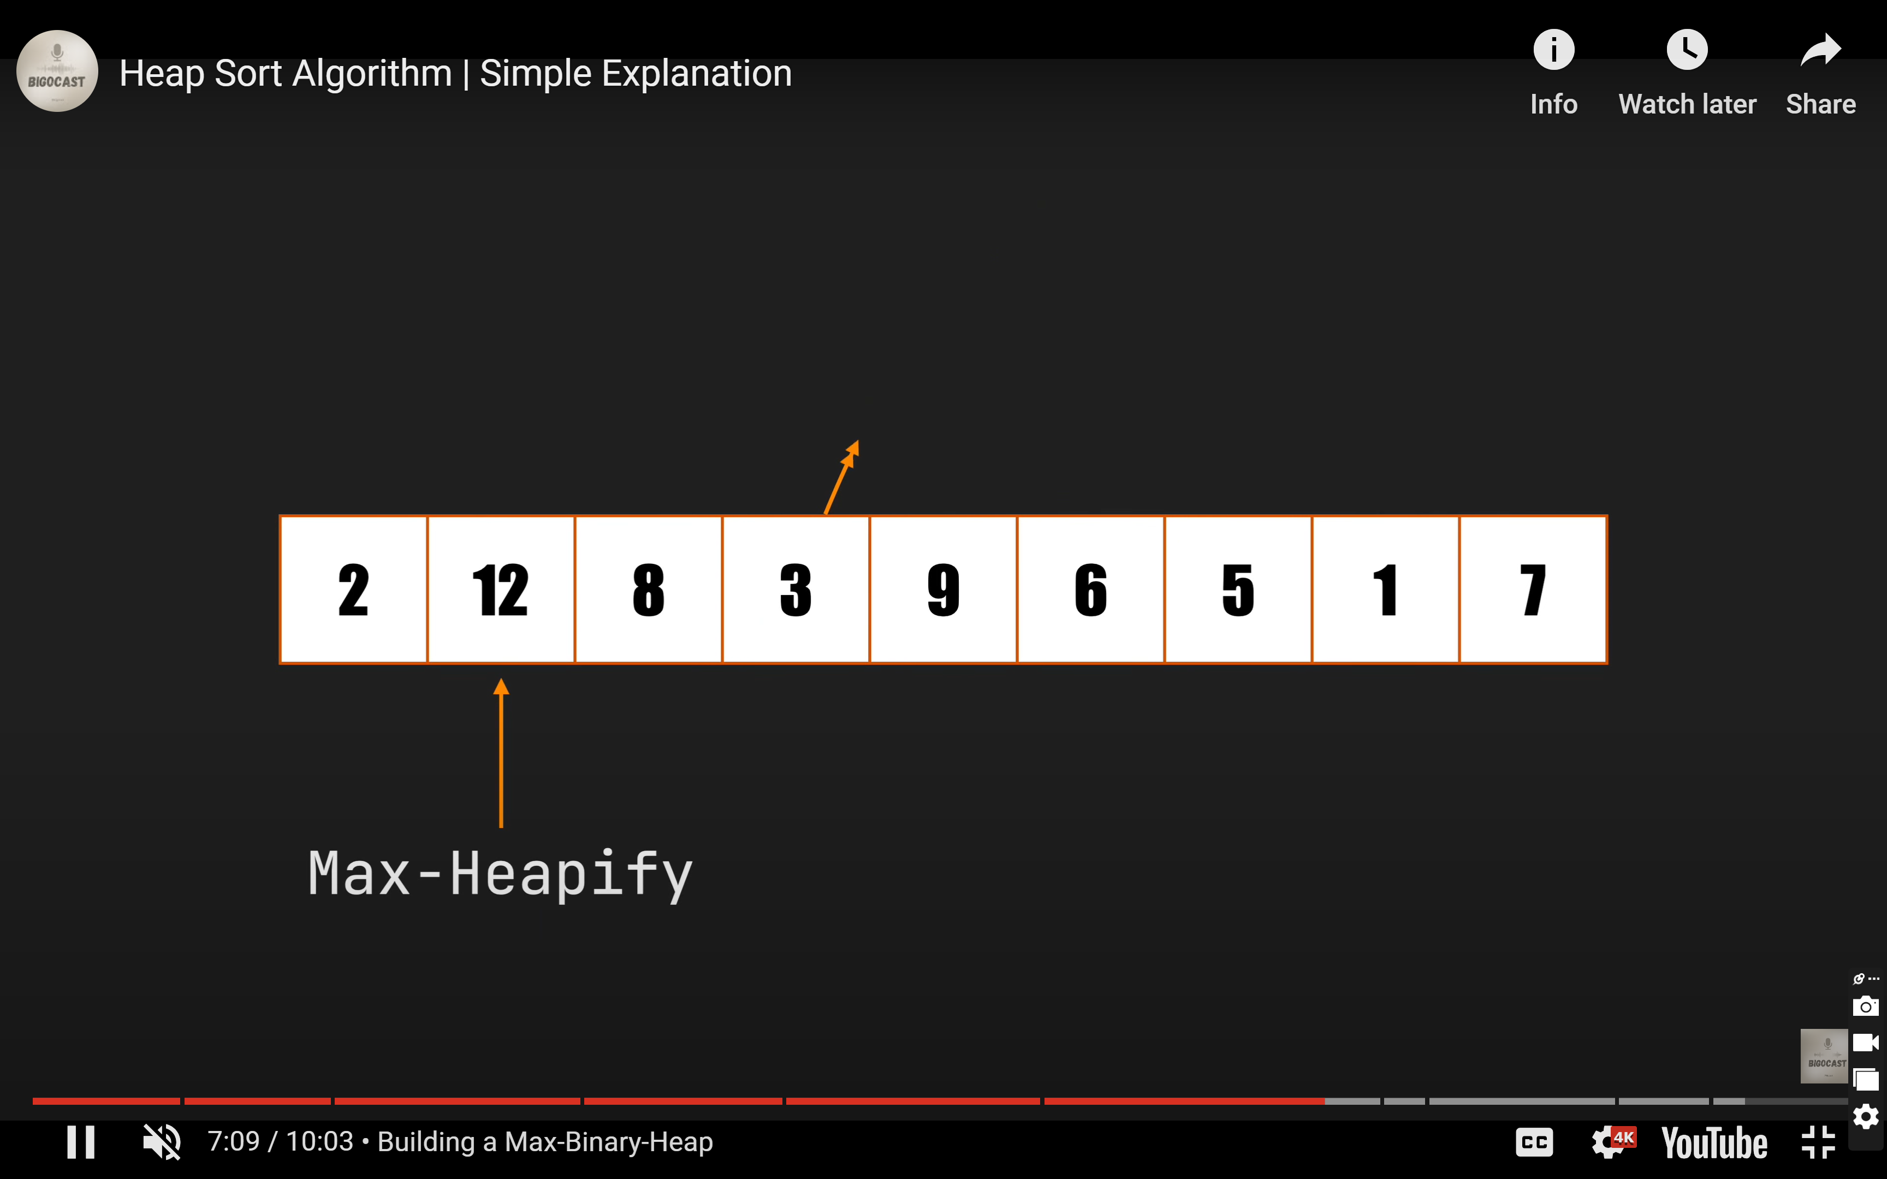





using System;

namespace HeapSortDemo

{

public class example

{

static void heapSort(int[] arr, int n)

{

for (int i = n / 2 - 1; i >= 0; i--)

heapify(arr, n, i);

for (int i = n - 1; i >= 0; i--)

{

int temp = arr[0];

arr[0] = arr[i];

arr[i] = temp;

heapify(arr, i, 0);

}

}

static void heapify(int[] arr, int n, int i)

{

int largest = i;

int left = 2 \* i + 1;

int right = 2 \* i + 2;

if (left < n && arr[left] < arr[largest])

largest = left;

if (right < n && arr[right] < arr[largest])

largest = right;

if (largest != i)

{

int swap = arr[i];

arr[i] = arr[largest];

arr[largest] = swap;

heapify(arr, n, largest);

}

}

public static void Main()

{

int[] arr = { 55, 25, 89, 34, 12, 19, 78, 95, 1, 100 };

int n = 10, i;

Console.WriteLine("Heap Sort");

Console.Write("Initial array is: ");

for (i = 0; i < n; i++)

{

Console.Write(arr[i] + " ");

}

heapSort(arr, 10);

Console.Write("\nSorted Array is: ");

for (i = 0; i < n; i++)

{

Console.Write(arr[i] + " ");

}

}

}

}